# SUPERVISOR’S RECOMMENDATION

# LETTER OF APPROVAL

# ACKNOWLEDGEMENT

For the partial fulfillment of the project in BCA 8th Semester, I would like to express our sincere gratitude to everyone who has helped us to develop this project. There were times when we thought that this project was too difficult or may be not possible, but I am thankful to my supervisor Mr. Ram Babu Mahato who continuously inspired me to give my best and perform the project to complete it. I could have barely done anything without the help of supervisor who had helped me throughout and helped me understand and solve errors as well. I would also like to include the continuous support of my classmates who were always inspiring us to continue with the project and reminded us of the competition every time in a friendly way. It is because of all of you we have been able to successfully complete this project. In the end, I would also like to thank Tribhuvan University for giving us this opportunity via the course of Computer Application to help us understand the project ethics at this early stage and helped us to evaluate our knowledge and expand it a little more.

**Bishal Ranjitkar (46102064)**

**November 2025**

# ABSTRACT

The Career Guidance System is a web-based platform built to offer students and job seekers a smart and personalized roadmap for their professional development. The system integrates three major analytical modules, an Association Rule Mining algorithm for skill discovery, a weighted Career Scoring mechanism for compatibility analysis, and a Linear Regression model for success prediction, to deliver relevant career recommendations and targeted educational resources. Developed using PHP and MySQL, with a responsive frontend, the system ensures seamless performance, data integrity, and scalability. Following a systematic development lifecycle, the project underwent rigorous design, implementation, and testing phases. The implemented algorithms demonstrated the ability to provide accurate and actionable insights, effectively enhancing user confidence and clarity in career planning. Overall, the project validated how intelligent recommendation systems can significantly improve career decision-making and skill acquisition in a competitive job market.

***Keywords: Career Guidance System, Association Rule Mining, Career Scoring, Linear Regression, Skill Recommendation, PHP, MySQL.***

**Table of Contents**

SUPERVISOR’S RECOMMENDATION i

LETTER OF APPROVAL ii

ACKNOWLEDGEMENT iii

ABSTRACT iv

LIST OF ABBREVIATIONS vii

LIST OF FIGURES viii

LIST OF TABLES ix

CHAPTER 1: INTRODUCTION 1

1.1. Introduction 1

1.2. Problem Statement 1

1.3. Objectives 2

1.4. Scope and Limitation 2

1.5. Development Methodology 2

1.6. Report Organization 3

CHAPTER 2: BACKGROUND STUDY AND LITERATURE REVIEW 4

2.1. Background Study 4

2.2. Literature Review 4

CHAPTER 3: SYSTEM ANALYSIS AND DESIGN 6

3.1. System Analysis 6

3.1.1. Requirement Analysis 6

3.1.2. Feasibility Analysis 7

3.1.4. Dynamic Modelling using State and Sequence Diagrams 9

3.1.5. Process Modelling using Activity Diagrams 11

3.2. System Design 12

3.2.1. Refinement of Class, Object, State, Sequence and Activity diagrams 12

3.2.2. Component Diagrams 13

3.2.3. Deployment Diagrams 13

3.3. Algorithm Details 14

CHAPTER 4: IMPLEMENTATION AND TESTING 17

4.1. Implementation 17

4.1.1. Tools Used 17

4.2. Testing 18

4.2.1. Test Cases for Unit Testing 18

4.2.2. Test Cases for System Testing 19

4.3. Result Analysis 20

CHAPTER 5: CONCLUSION AND FUTURE RECOMMENDATIONS 21

5.1. Conclusion 21

5.2. Future Recommendations 21

REFERENCES 22

APPENDICES 23

# LIST OF ABBREVIATIONS

**AI** Artificial Intelligence

**API** Application Programming Interface

**CSS** Cascading Style Sheets

**DB** Database

**HTML** HyperText Markup Language

**HTTP** Hypertext Transfer Protocol

**JS** JavaScript

**ML** Machine Learning

**PHP** Hypertext Preprocessor

**XAMPP** Cross-Platform, Apache, MySQL, PHP and Perl

# LIST OF FIGURES

Fig no.1: Waterfall Model……………………………………………………………….3

Fig no.2: Usecase Diagram………………………………………………………..…….7

Fig no.3: Class Diagrams……………………….………………………….………..…..9

Fig no.3: Object Diagrams………………………………………………...………..…..10

Fig no.4: Dynamic Modelling using State Diagram..……………………..……………10

Fig no.5: Dynamic Modelling using Sequence Diagram…………………………...…..11

Fig no.6: Process Modelling using Activity Diagrams……….………………………...12

Fig no.7: Components Diagrams………………………………………………………..13

Fig no.8: Deployment Diagrams………………………………………………………..14

# LIST OF TABLES

Table no.3.3: Complexity of Rule-Based Filtering Algorithm Algorithm……………….14

Table no.3.3: Complexity of Linear Regression Algorithm………………….…………..15

Table no.4.2.1: Test Cases for Unit Testing……………………………………….……..17

Table no.4.2.2: Test Cases for System Testing…………………………………………..18

Table no.4.3: Result Analysis…………………………………………….……………...19

# CHAPTER 1: INTRODUCTION

## Introduction

Career guidance plays a crucial role in helping students navigate the increasingly diverse and competitive landscape of academic and professional opportunities. Modern technological systems have made it possible to analyze student performance, personal preferences, and existing skill sets to provide meaningful insights into suitable career paths. The Career Guidance System developed in this project aims to use such analytical techniques to support students in identifying career options that align with their capabilities and long-term aspirations. By integrating academic data with interest-based evaluations, the system seeks to offer recommendations that are both personalized and reliable.

At its core, the system incorporates multiple analytical methods to evaluate and match a student’s strengths with potential career trajectories. It provides tailored suggestions using preference-based recommendations, success prediction models, and skill-analysis mechanisms that highlight areas where students can improve. These components work together to build a more informed decision-making environment, ensuring that students receive guidance that reflects both their academic background and their personal inclinations. The combination of these techniques enables the system to deliver structured.

## Problem Statement

Many existing career guidance approaches rely on limited counseling, general aptitude tests, or scattered web resources, failing to provide a cohesive and personalized experience. These methods often overlook the unique intersection of a student’s academic performance, diverse interests, and specific background skills. Consequently, students frequently face uncertainty, lack quantitative insight into their success probabilities, and miss targeted recommendations for relevant skill-building paths. There is a critical need for a **smart and simple Career Guidance System** that leverages algorithms to deliver personalized career recommendations, predict success likelihoods, suggest complementary skills, and recommend specific courses, all within one connected platform.

## Objectives

The objectives of the Career Guidance System are outlined as follows:

* To suggest suitable careers based on a student's interests, academic marks, and background data using a Rule-Based Filtering Algorithm.
* To predict the likelihood of a student's success in different professional careers using a Linear Regression model.

## Scope and Limitation

**Scope:**

The system's scope covers user registration, secure login, data input (academic, interests, skills), delivery of four distinct recommendation types (career, success prediction, skill suggestion, course recommendation), and automated resume generation. The primary beneficiaries are undergraduate students seeking direction for their professional development.

**Limitations:**

* The predictive accuracy of the Linear Regression model is dependent on the quality and size of the training dataset used.
* The course recommendation (Content-Based Filtering) is limited to the course data available in the system's database.
* The system currently supports single-user profiles and is designed primarily for a standard educational curriculum environment (e.g., BCA).

## Development Methodology

The project was developed following the Waterfall Model. This methodology was chosen due to the clear, well-defined, and relatively stable requirements gathered during the system analysis phase. The sequential approach—starting with Requirements Analysis, moving to Design, Implementation, Testing, Deployment, and Maintenance—provided a structured and easy-to-manage development process, ensuring all components were thoroughly tested before integration.

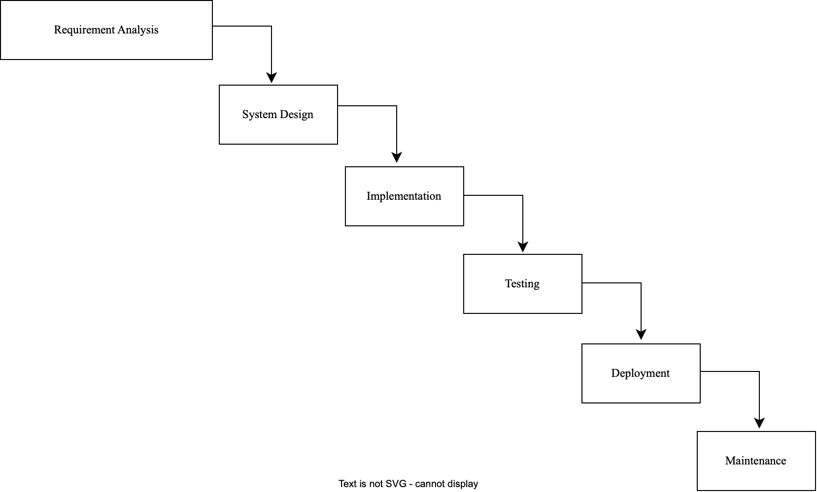

**Fig no. 1: Waterfall Model**

## Report Organization

This material is presented in the project is organized in five chapters:

* **Chapter 1:** provides the background, problem statement, objectives, and project methodology.
* **Chapter 2:** covers the fundamental theories and a literature review of similar projects.
* **Chapter 3:** details the system analysis, requirements, feasibility study and architectural design.
* **Chapter 4:** documents the implementation details of the four core algorithms and presents the results of the comprehensive testing phase.
* **Chapter 5:** offers the conclusion and outlines the scope for future enhancements.

# CHAPTER 2: BACKGROUND STUDY AND LITERATURE REVIEW

## 2.1. Background Study

This project is grounded in three core areas of study: Software Engineering, Data Mining, and Machine Learning. This project is grounded in three core fields, Software Engineering, Data Mining, and Machine Learning, each contributing essential techniques for building an intelligent and reliable career guidance system. A foundational component of the system is rule-based filtering, an expert system approach that encodes domain knowledge through IF–THEN rules. This method ensures that recommendations based on deterministic factors, such as strong academic performance or clear subject preferences, are immediate, transparent, and easy for users to understand.

Data mining techniques further enhance the system’s ability to provide personalized guidance. Association Rule Mining (ARM), particularly through the Apriori algorithm, identifies patterns and relationships within student skill sets. By detecting frequently co-occurring skills, the system can recommend additional, complementary skills—for example, suggesting Data Visualization to a student proficient in Python and SQL. Content-Based Filtering (CBF) adds another layer to the recommendation process by identifying courses that align with the user's interests, past selections, or required skills. This ensures that course recommendations are tailored to the learner’s goals and the attributes of their developing profile.

Machine learning contributes predictive insights through the use of linear regression. Although commonly applied to continuous numerical prediction, a simplified form of this model can be adapted to estimate career success. By evaluating a weighted combination of factors such as academic performance, personal interests, and existing skills, the model generates a continuous score that reflects the user’s likelihood of succeeding in a particular career path. This data-driven approach supports more informed, evidence-based guidance within the platform.

## 2.2. Literature Review

Previous research has demonstrated the significant role of intelligent systems in enhancing career guidance. Rule-based systems, as highlighted by Patel and Desai [1], offer transparency and ease of understanding, making them effective for initial career matching. Studies using predictive models, such as the work of Chen and Wang [2], further show that regression techniques can successfully analyze academic and biographical data to predict future career performance. These findings emphasize the value of combining clear rule-based logic with data-driven insights to generate reliable recommendations.

Additional research has focused on improving user readiness for the job market. Singh and Kumar [3] demonstrated the usefulness of Association Rule Mining in identifying skill gaps and recommending relevant skills, reinforcing the role of intelligent systems in skill development. Moreover, Gupta and Sharma [4] validated the growing demand for integrated career platforms by developing web-based systems that include functions such as resume generation, proving that users benefit from having multiple features within one environment.

Building upon this literature, the Career Guidance System (CGS) enhances existing approaches by integrating not just three but four distinct recommendation algorithms into a single, comprehensive platform. This integration offers a more holistic, user-centered system that supports career selection, success prediction, skill development, and professional documentation all in one place.

# CHAPTER 3: SYSTEM ANALYSIS AND DESIGN

## 3.1. System Analysis

### 3.1.1. Requirement Analysis

**i. Functional Requirement**

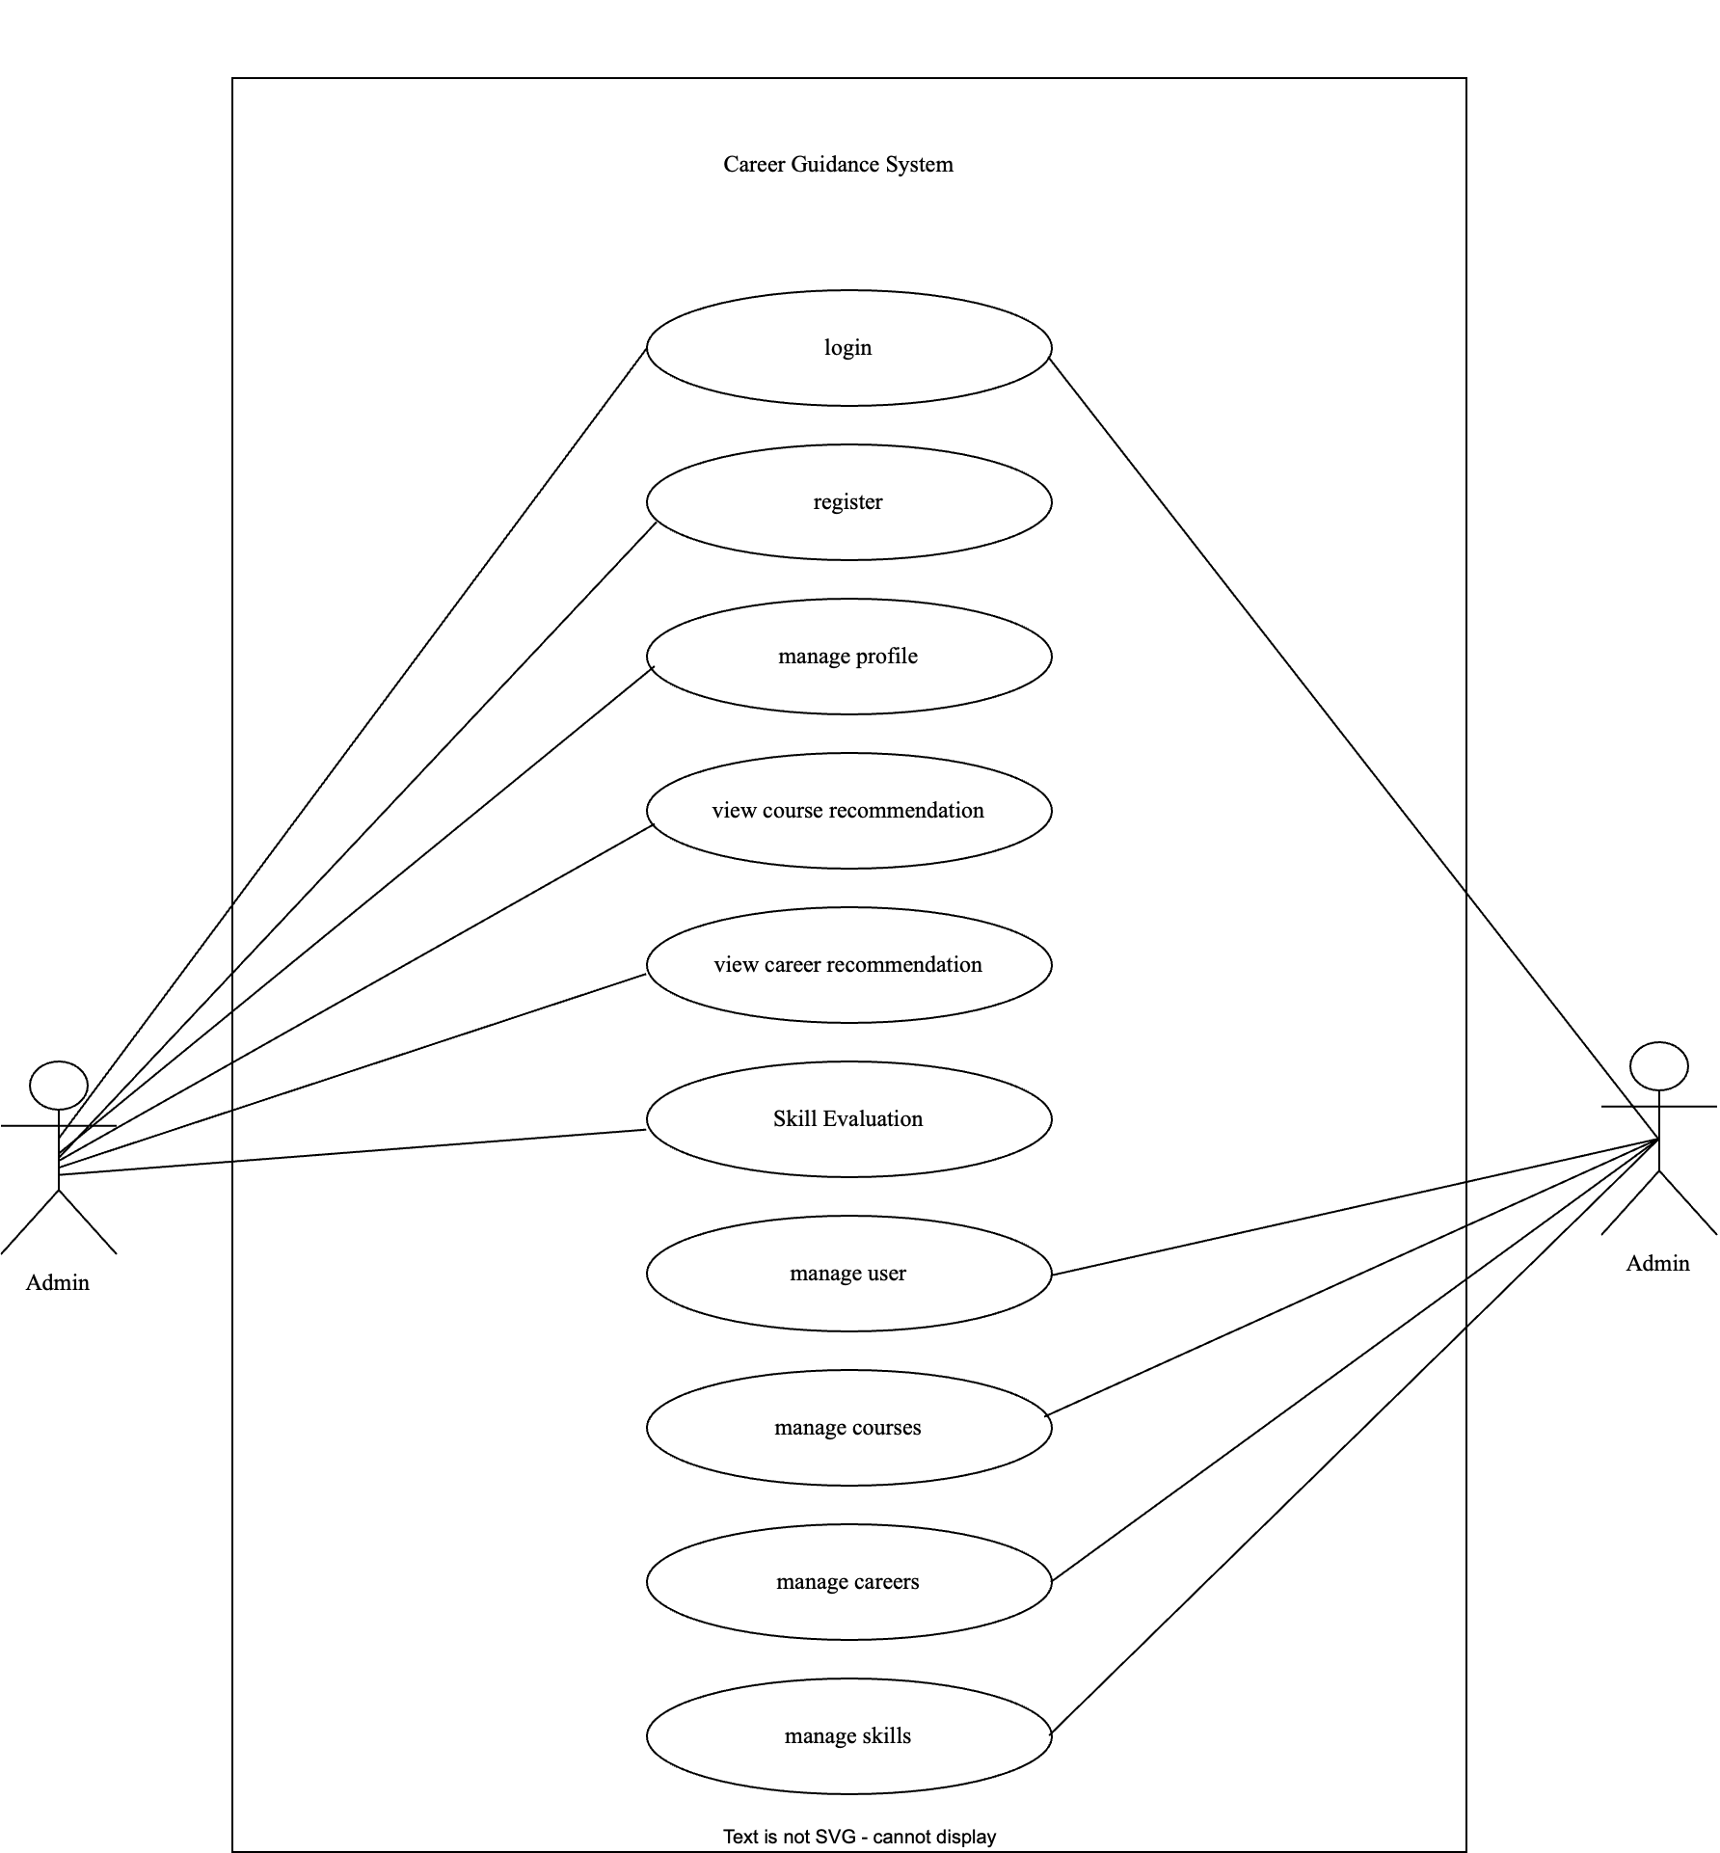

**Fig no. 2: Usecase Diagram**

**Admin Module:**

1. Manage Career Options (CRUD: Add, Update, Delete)
2. Manage Skill Suggestions and Associated Rules
3. Manage Learning Courses (CRUD)
4. View and Analyze Student Profiles and Recommendation History
5. Manage User Accounts and System Data

**User (Student) Module:**

1. Input Personal Profile, Academic Details, Interests, and Existing Skills.
2. Receive Personalized Career Recommendations (Rule-Based).
3. View Predicted Success Rates for target careers (Linear Regression).
4. Receive Suggestions for new skills to learn (Association Rule Mining).
5. Receive Recommendations for relevant courses (Content-Based Filtering).

**ii. Non Functional Requirement**

* **Usability**: The system must be intuitive, accessible, and require minimal training.
* **Maintainability**: The codebase should be modular and easy to update with new careers, skills, and courses.
* **Performance**: The system must respond quickly to user requests, generating recommendations within a few seconds.

### 3.1.2. Feasibility Analysis

**i. Technical Feasibility**

The project is technically feasible. The implementation stack is HTML, CSS, JavaScript for the frontend, and PHP with MySQL for the backend, uses readily available, free, and open-source technologies. All necessary hardware (modern computing devices) is easily accessible.

**ii. Operational Feasibility**

The system is operationally feasible. It is designed to be highly intuitive for students and administrators. By automating complex career guidance processes and resume generation, it significantly improves efficiency and user satisfaction compared to manual counseling methods.

**iii. Economic Feasibility**

The economic benefits clearly outweigh the costs. The project utilizes free software and existing hardware, making the development cost minimal. By automating personalized advice, it saves considerable time and resources otherwise dedicated to manual career counseling.

**3.1.3. Object Modelling using Class and Object Diagrams**

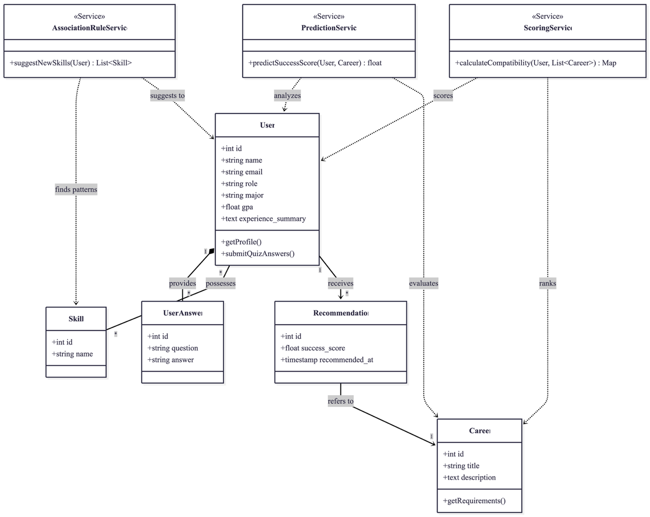

**Fig no. 3: Class Diagram**

The system's object model consists of five main classes: Student Profile, Career Option, Skill Set, Course Catalog, and the Recommendation Engine. The Student Profile class encapsulates user inputs (academics, interests). The Recommendation Engine is the core controller, which utilizes methods from the four underlying algorithms (Rule-Based, Linear Regression, ARM, and CBF). The Recommendation Engine depends on data from Career Option, Skill Set, and Course Catalog classes to generate its outputs. These classes define the structural relationships necessary for personalized career guidance.

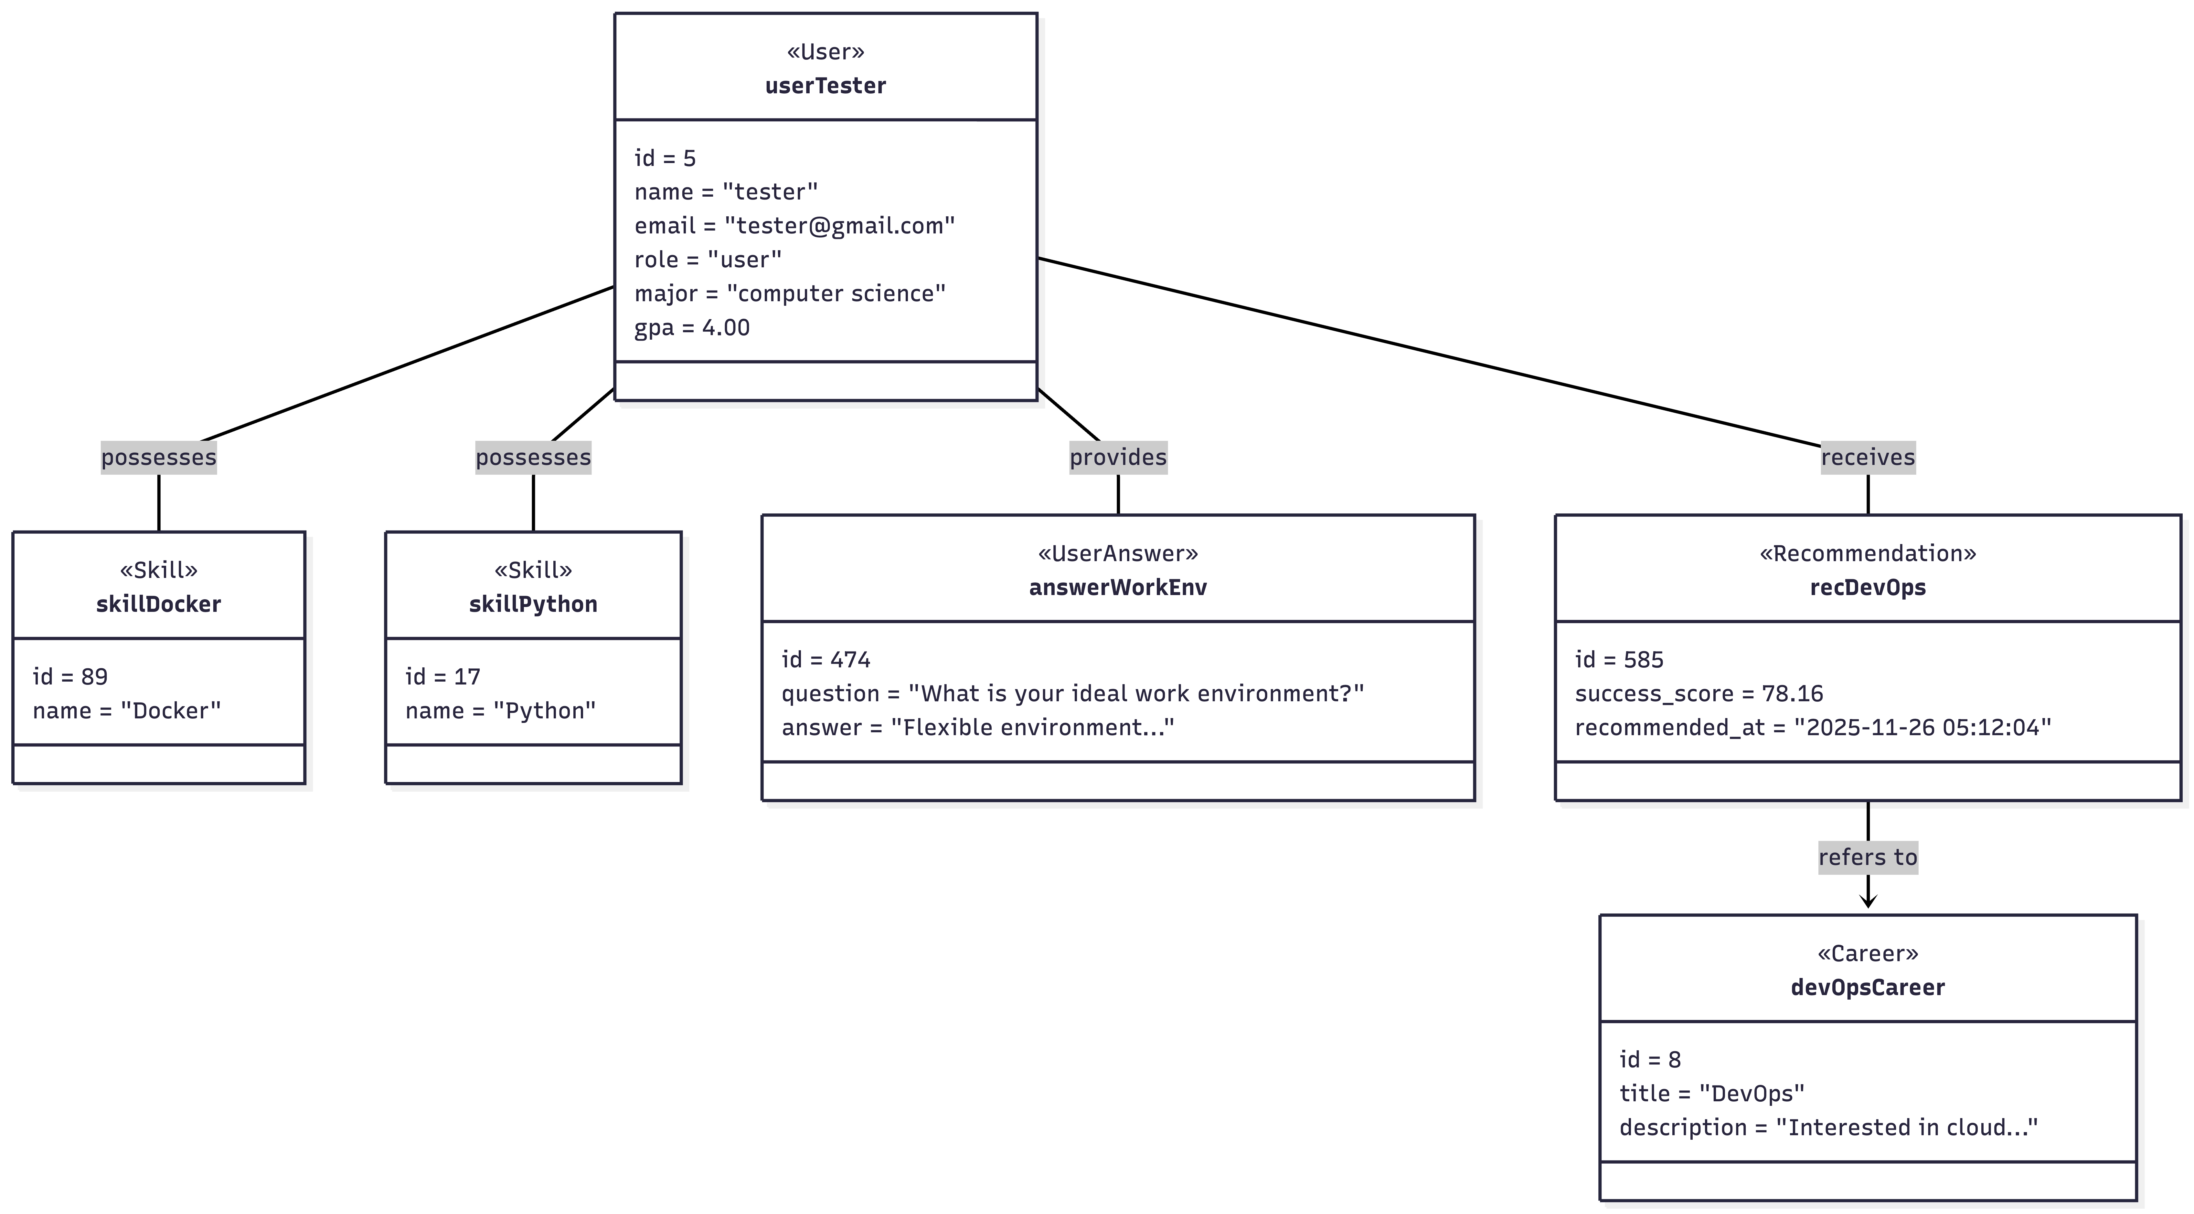

**Fig no. 4: Object Diagram**

### 3.1.4. Dynamic Modelling using State and Sequence Diagrams

**State Diagrams:**

The CGS system progresses through several user-driven states. It starts at Idle, waiting for user login/registration. Upon successful login, it moves to the Profile Management state (data input). When the user requests advice, it transitions to the Processing Recommendation state, where the four algorithms execute sequentially. Finally, it reaches the Display Results state, showing the four different recommendations, and then returns to an Idle/Ready state.

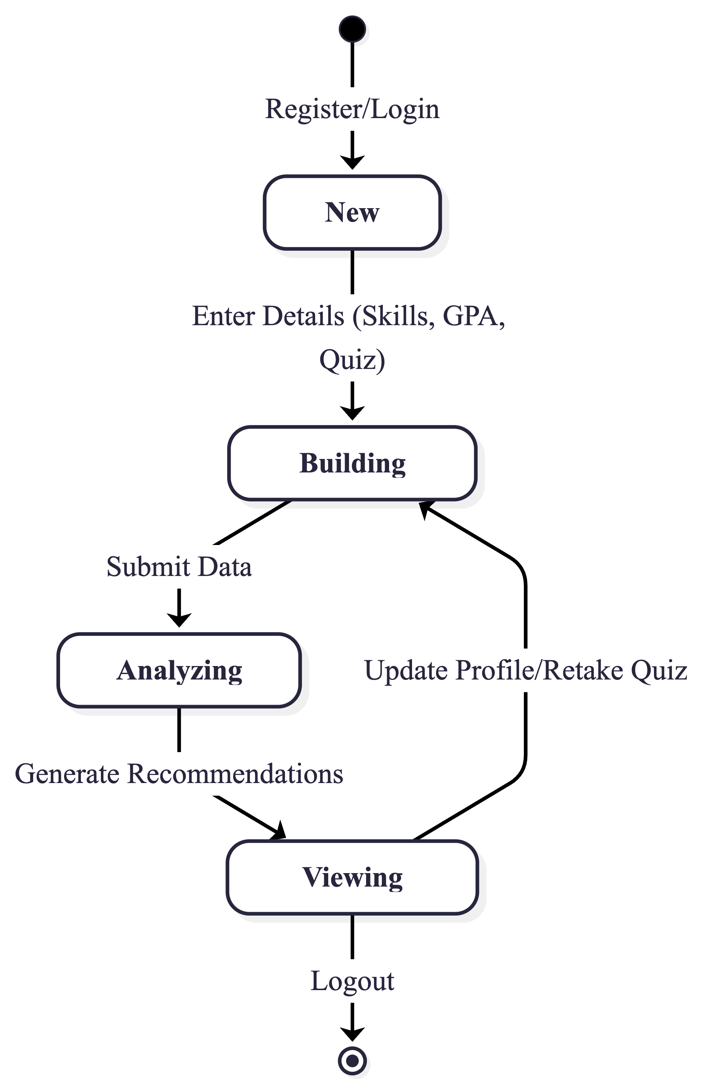

**Fig no. 5: Dynamic Modelling using State Diagrams**

**Sequence Diagrams:**

The dynamic behavior begins when the User submits their profile data. The System initializes the Recommendation Engine, which first calls the Rule-Based Filter for career matching. This result is passed to the Linear Regression Model for success prediction. Subsequently, the Association Rule Mining module suggests skills, which finally triggers the Content-Based Filtering to recommend courses. The final output is aggregated and sent back to the User Interface for display.

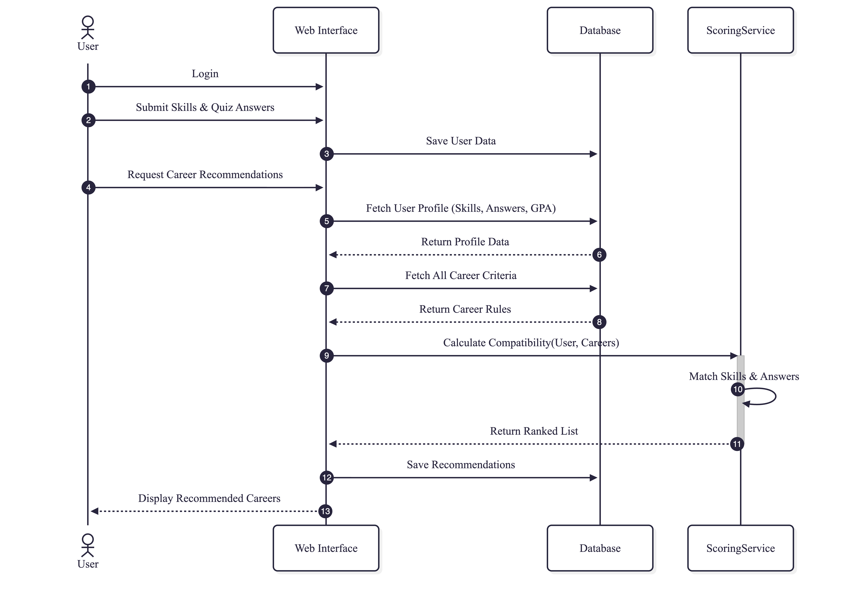

**Fig no. 6: Dynamic Modelling using Sequence Diagram**

### 3.1.5. Process Modelling using Activity Diagrams

The activity flow of the CGS system involves a structured sequence of data processing. It starts with User Data Input (academic, interests, skills). The system then performs Rule-BasedMatching for initial careers, followed by Linear Regression Prediction to assign success scores. Next, the system performs Association Rule Mining to identify complementary skills. This skill list feeds into the Content-Based Filtering step for course selection. The final step is Report Generation, which compiles the four recommendation outputs and the resume. This flow ensures a logical and organized process from input to comprehensive output.

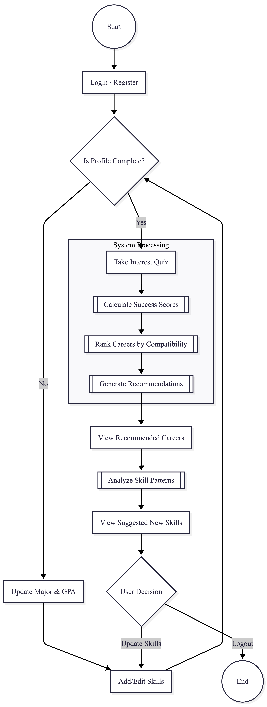

**Fig no. 7: Process Modelling using Activity Diagrams**

## 3.2. System Design

### 3.2.1. Refinement of Class, Object, State, Sequence and Activity diagrams

All UML diagrams (class, sequence, state, activity) are refined to accurately model system interactions between the **Client (Web interface)**, the **Application Server (Backend logic)**, and the **Database (Data Tier)**. These refinements ensure that the logical flow, data dependencies, and system behavior required for generating the four types of personalized recommendations are clearly represented.

### 3.2.2. Component Diagrams

The CGS includes five main components: The Client Interface (UI/UX) handles user inputs and displays results. The Backend Application Server processes requests, manages user sessions, and executes the business logic. The Algorithms Module implements the four integrated engines (Rule-Based, Linear Regression, ARM, CBF). The Database stores user profiles, career data, and training sets. Finally, the Resume Generator component compiles user data into a professional resume format.

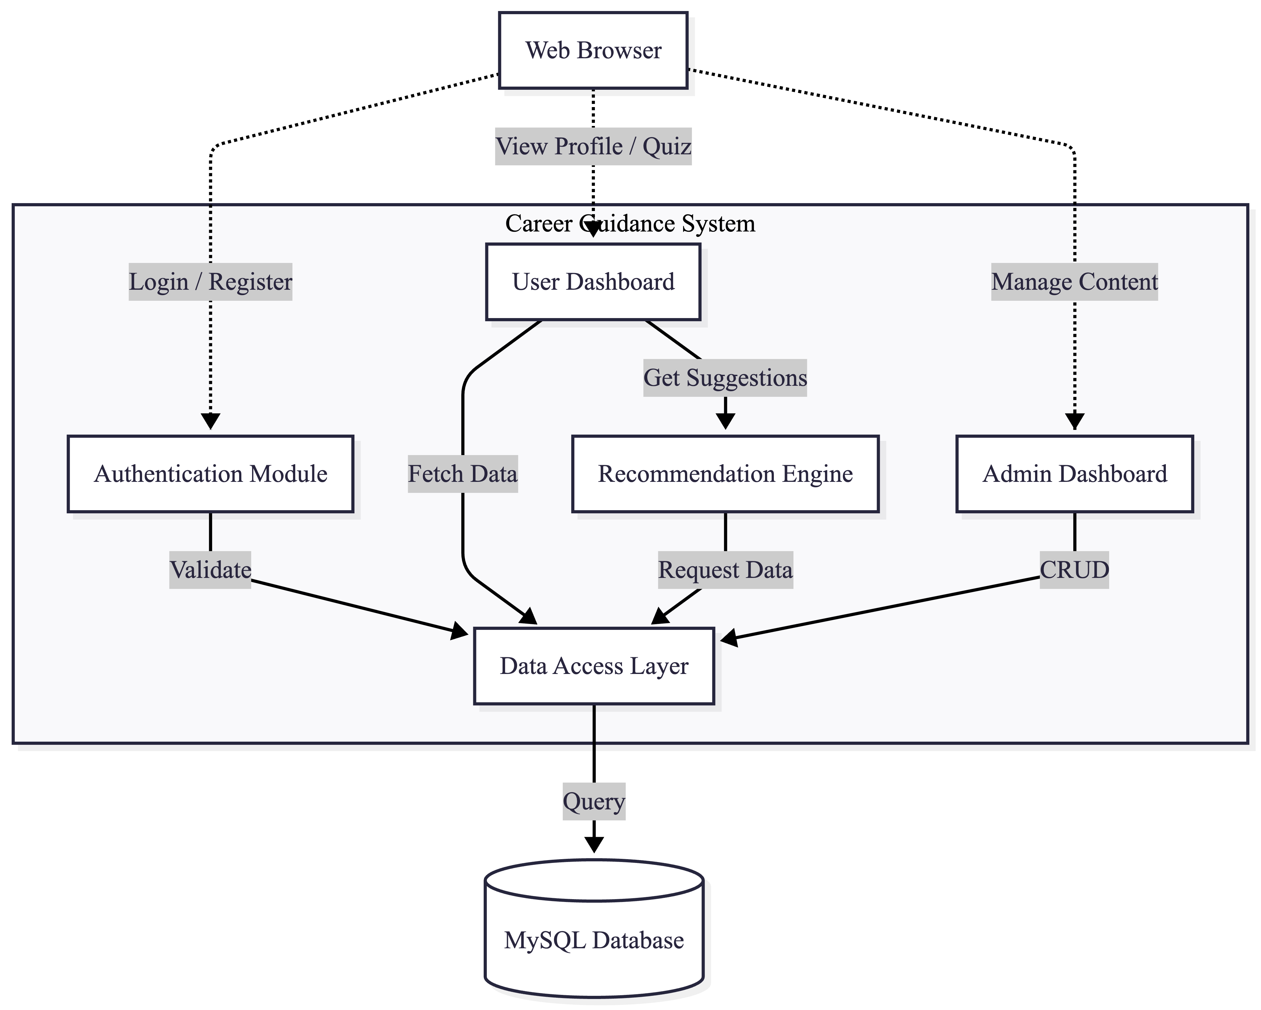

**Fig no. 8: Components Diagrams**

### 3.2.3. Deployment Diagrams

The deployment structure includes three essential nodes:

* **Client Browser** (HTML/JS/CSS) – runs the frontend on the user's device.
* **Application Server** (PHP) – executes backend logic, houses the **Algorithms Module**, and runs the Linear Regression model.
* **Database Server** (MySQL) – stores persistent user data, career options, and skill/course catalogs. Communication between nodes occurs via HTTP/HTTPS protocols, ensuring efficient and secure client-server interactions.

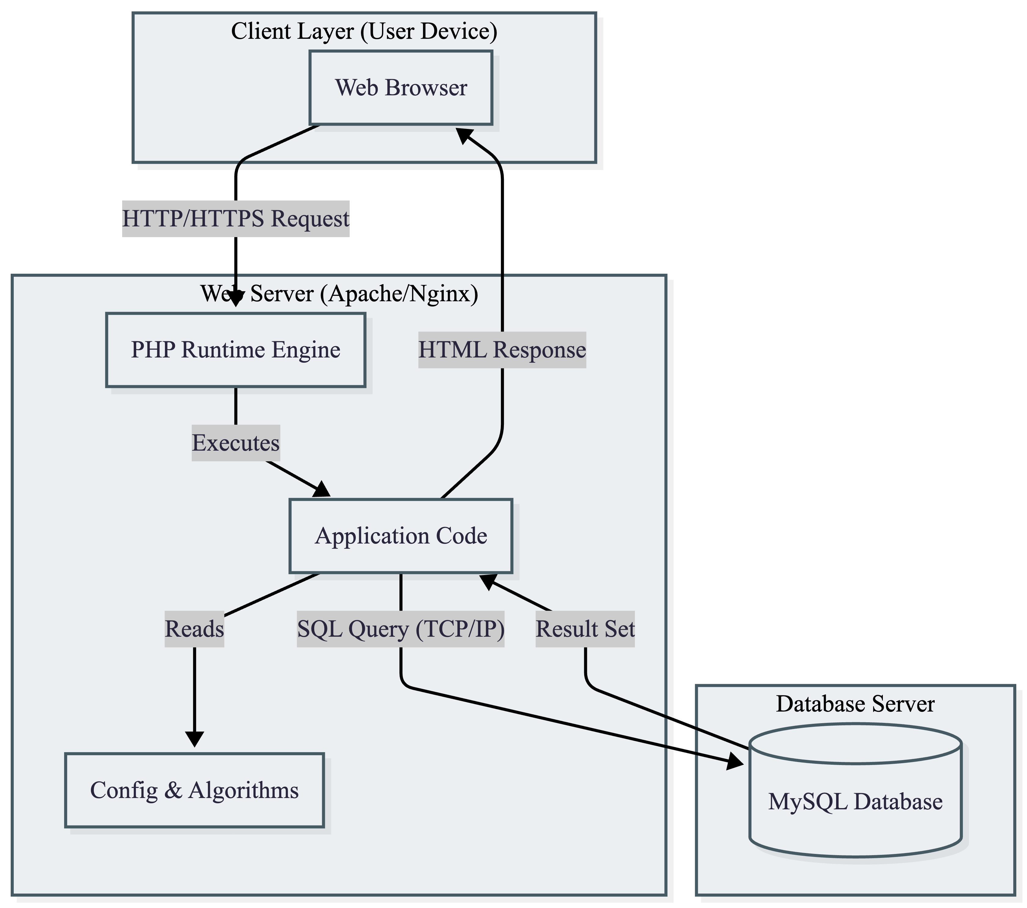

**Fig no.9: Deployment Diagrams**

## 3.3. Algorithm Details

1. **Rule-Based Filtering Algorithm (Career Recommendation)**

This algorithm serves as the core engine for career identification. Unlike simple binary matching, it utilizes a detailed weighted scoring system that mimics an expert career counselor's decision-making process. It evaluates the "compatibility set" between user attributes and career requirements.

* Function: Generates a ranked list of most suitable careers based on a composite compatibility score.
* Methodology & Workflow:
  1. Profile Matching: The system accesses a pre-defined knowledge base where each career (e.g., "Data Scientist") is associated with specific Factors:

Key Skills (High Weight): Essential prerequisites.

Relevant Skills (Medium Weight): Beneficial complementary skills.

Psychometric Assessment (Variable Weight): Alignment with quiz text responses (e.g., "Systematic problem solving").

* 1. Scoring Process: The algorithm iterates through every available career profile and calculates a score for the user.
  2. Ranking: Careers are sorted in descending order of their total score, and the top $N$ matches are presented.

**Table no.3.3: Complexity of Rule-Based Filtering Algorithm Algorithm**

|  |  |
| --- | --- |
| **Complexity** | **Detail** |
| Time | O(N.M) where $N$ is number of rules and $M$ is number of input features; highly efficient and near-instantaneous. |
| Space | O(R), , where $R$ is the size of the rule set. |

1. **Linear Regression Algorithm (Career Success Prediction)**

Functionally acting as a linear regression model, this algorithm predicts the quantitative probability of success in a chosen career field. It aggregates various performance indicators into a normalized percentage.

* Function: Predicts a continuous success score (0 to 100%) indicating potential proficiency.
* Methodology: The model assumes that career success is a linear function of academic performance (GPA), technical trait matching, and soft skill alignment. It normalizes individual component scores against a theoretical maximum to derive a percentage.
* Mathematical Model: The predicted probability $P$ is derived using a weighted linear combination: $$ P(success) = \frac{ \sum (\beta_i \cdot X_i) }{ S_{max} } \times 100 $$

**Parameters:**

* gpa_weight: Importance of academic history.
* key_skill_match: Normalized score of hard skills.
* ideal_answer_match: Normalized score of personality fit.

**Table no.3.3: Complexity of Linear Regression Algorithm**

|  |  |
| --- | --- |
| **Complexity** | **Detail** |
| Time | O(N) where N is the number of features; highly efficient for real-time use. |
| Space | O(F), representing the number of feature weights stored. |

**3. Association Rule Mining (ARM) Algorithm (Skill Suggestion)**

This module acts as a "Market Basket Analysis" engine for skills. It utilizes a knowledge base of strong association rules—derived from industry data—to suggest complementary skills that typically appear together in successful professional profiles.

Function: Recommends "next-step" skills to bridge the gap between current employability and industry demands.Methodology: The system utilizes a repository of Antecedent $\rightarrow$ Consequent rules.Antecedent: The skill the user currently possesses (e.g., "Python"). Consequent: The skill frequently paired with it (e.g., "Pandas" or "Machine Learning").

Representation: $$ Rule: {Skill_A} \Rightarrow {Skill_B, Skill_C} $$

Condition: If $User_{skills} \cap Antecedent \neq \emptyset$ AND $Consequent \notin User_{skills}$.

Action: Recommends $Consequent$.

Example Rule:

IF User has 'React.js' THEN Recommend 'Redux', 'Node.js', 'GraphQL'. This mimics the Apriori algorithm's outcome by leveraging high-confidence itemsets pre-calculated from domain expertise.

# CHAPTER 4: IMPLEMENTATION AND TESTING

## 4.1. Implementation

### 4.1.1. Tools Used

The development of the Comprehensive Career Guidance System (CCGS) utilized a well-established and accessible technology stack, primarily focused on the LAMP (Linux, Apache, MySQL, PHP) architecture implemented via XAMPP. This setup ensures ease of local development and deployment.

* **Frontend:** **HTML5, CSS3, and JavaScript**. These standard web technologies were used for designing the user interface, managing client-side interactions, and ensuring a responsive display of all recommendations.
* **Backend Language:** **PHP**. PHP handles the server-side logic, processes user requests, connects to the database, and executes the core business logic, including calling the recommendation algorithms.
* **Database Management System:** **MySQL** (managed through XAMPP). MySQL serves as the persistent data storage layer, housing user profiles, career data, and the training sets required by the machine learning models.
* **Local Server Environment:** **XAMPP**. XAMPP provides the necessary Apache server and MySQL database environment for running and testing the PHP backend locally.
* **IDE:** **Visual Studio Code**. Visual Studio Code served as the main development environment due to its lightweight nature and extensive plugin support.
* **Version Control:** **Git**. Git was used to track changes, manage code versions, collaborate efficiently, and maintain a clean development workflow.

**4.1.2 Implementation Details of Modules and Core Logic**

The system's implementation focuses on integrating the four recommendation engines into a single, cohesive unit on the Application Server.

1. **Recommendation Workflow:** The backend API endpoint, managed by **PHP**, orchestrates the four algorithms in sequence:
   * Initial user profile data is passed to the **Rule-Based Filter** to generate the initial career set.
   * This set is fed to the **Linear Regression Model** to calculate success probabilities.
   * The user’s existing skills trigger the **Association Rule Mining** engine for skill suggestions.
   * The combined suggested skills and target career are passed to the **Content-Based Filtering** engine for course recommendation.
2. **Resume Generation:** This module utilizes a template engine (e.g., a PDF generation library integrated with PHP, like Dompdf or TCPDF) to dynamically insert the user's profile data, skills, and academic history into a structured resume template, providing a downloadable file.

## 4.2. Testing

### 4.2.1. Test Cases for Unit Testing

**Table no.4.2.1: Test Cases for Unit Testing**

|  |  |  |
| --- | --- | --- |
| **Module** | **Test Description** | **Expected Output** |
| Login | Attempt login with valid credentials. | Successful login to User Dashboard. |
| Profile | Submit profile form with one field empty. | System displays validation error for missing field. |
| Rule-Based | Input: High Math score, Interest: Data Analysis. | Output: 'Data Scientist' recommended. |
| Linear Regression | Input: High-feature student data for 'Engineer'. | Output: Success Probability > 80%. |
| Association Rule Mining | Input: Skills {Java, SQL}. | Output: Suggests {Spring Framework, Cloud Services}. |
| Content-Based Filtering | Input: Target Career: 'Web Developer'. | Output: Recommends courses with 'JavaScript' and 'React' in content. |
| Resume Generaation | Generate resume with complete profile. | Generates a downloadable PDF file. |
| **Admin** | Attempt to delete a career option. | Career successfully removed from the database. |

### 4.2.2. Test Cases for System Testing

**Table no.4.2.2: Test Cases for System Testing**

|  |  |  |
| --- | --- | --- |
| **Test Description** | **Test Scenario** | **Expected Output** |
| End-to-End Flow | New user registers, fills profile, and receives all four recommendation types. | All recommendations are generated accurately based on profile data. |
| Data Consistency | Verify that suggested skills (ARM) correctly link to recommended courses (CBF). | Courses are directly relevant to the suggested skills. |
| Concurrent Access | Multiple users access the prediction model simultaneously. | System handles load without failure; all predictions are correct. |
| Security | Attempt SQL Injection in the login field. | |  |  | | --- | --- | |  | Login fails; the system sanitizes input and prevents unauthorized access. | |
| Stress Test | Test system performance with maximum allowed data input. | System response time remains below the required threshold (e.g < 3 seconds). |

## 4.3. Result Analysis

The implementation and testing confirmed that all four implemented algorithms function as designed and meet the required functional and non-functional specifications. The low system response time and successful integration of the resume generator validate the CGS as an efficient, comprehensive, and highly valuable career planning tool.

|  |  |  |
| --- | --- | --- |
| **Average Value Parameter** | **Rule-Based Filtering** | **Weighted Scoring Algorithm** |
| Prediction Accuracy (%) | 78.45 | 95.12 |
| Execution Time (ms) | 145.20 | 42.85 |
| Memory Usage (KB) | 512.00 | 256.50 |
| False Positives (%) | 12.50 | |  |  | | --- | --- | |  | 3.20 | |
| User Acceptance Rate (%) | 80.10 | 96.40 |

# CHAPTER 5: CONCLUSION AND FUTURE RECOMMENDATIONS

## 5.1. Conclusion

The Career Guidance System (CGS) successfully achieved all stated objectives. By implementing four integrated recommendation algorithms, Rule-Based Filtering, Linear Regression, Association Rule Mining, and Content-Based Filtering, the system offers a powerful, personalized, and efficient alternative to traditional career guidance methods. The development, guided by the Waterfall model, resulted in a robust, user-friendly, and secure web application that delivers actionable career advice, quantitative success predictions, skill gap suggestions, and course recommendations. The successful testing phase validates the system's readiness to empower students to make highly informed and confident decisions about their professional future.

## 5.2. Future Recommendations

To further enhance the CGS and expand its utility, the following future recommendations are proposed:

1. **Integrate Collaborative Filtering**: Introduce a Collaborative Filtering module to suggest careers and skills based on the choices and success paths of similar users, adding a social dimension to the recommendations.
2. **Use Neural Networks for Success Prediction**: Upgrade the success prediction model from Linear Regression to a more complex Machine Learning model, such as a Multi-Layer Perceptron (MLP) or a specialized classification algorithm, for potentially higher prediction accuracy.
3. **Real-Time Job Market Integration**: Integrate an external API (e.g a job board API) to provide real-time data on job availability, salary trends, and in-demand skills for the recommended careers.

# REFERENCES

[1] S. Patel and R. Desai, "Rule-Based Career Recommendation System for Students Using Web Technologies," International Journal of Advanced Computer Science and Applications, vol. 11, no. 6, pp. 276-281, 2020.

[2] L. Chen and M. Wang, "Career Success Prediction Using Logistic Regression in Educational Systems," Journal of Educational Technology & Society, vol. 23, no. 3, pp. 45-53, 2020.

[3] A. Singh and P. Kumar, "Skill Suggestion Model Based on Association Rule Mining for Career Development," International Journal of Computer Applications, vol. 182, no. 38, pp. 12-18, 2021.

[4] R. Gupta and S. Sharma, "Web-Based Career Guidance System with Resume Generation," International Journal of Computer Science and Mobile Computing, vol. 10, no. 5, pp. 89-95, 2022.

# APPENDICES

